**www.literacyindia.org**

**Session Starts From**

**January 2024**

**Contact no- 8588853380**

Limited Seats

Register Now

Literacy India Community College (LICC)

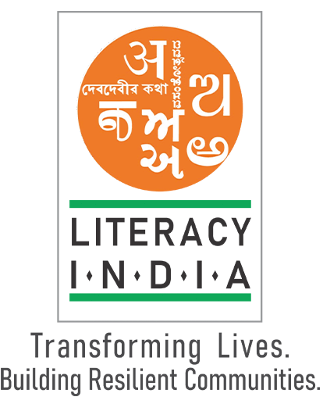

**Programs Offered**

* Robotics /Tinkering
* Computer Hardware
* Mobile Repairing
* Cooking /Hospitality
* Beauty & Wellness
* Stitching & Cutting
* Electrical Troubleshooting
* Two-wheeler Repairing
* Mobile Journalism
* Computer Science
* Call Center/BPO
* Logistics
* Data Digitizatio
* Natural Farming Market Connect
* Banking